1. How many types of conditions are available in conditional formatting on Excel?

Ans

They are grouped into **three categories**: Data Bars are horizontal bars added to each cell, much like a bar graph. Color Scales change the color of each cell based on its value. Each color scale uses a two- or three-color gradient.

Conditional formatting presets

Excel has several predefined styles—or **presets**—you can use to quickly apply conditional formatting to your data. They are grouped into three categories:

* **Data Bars** are horizontal bars added to each cell, much like a **bar graph**.

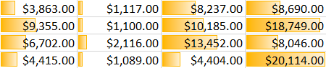

* **Color Scales** change the color of each cell based on its value. Each color scale uses a **two- or three-color gradient**. For example, in the **Green-Yellow-Red** color scale, the **highest** values are green, the **average** values are yellow, and the **lowest** values are red.

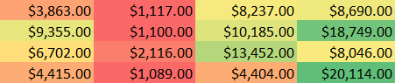

* **Icon Sets** add a specific icon to each cell based on its value.

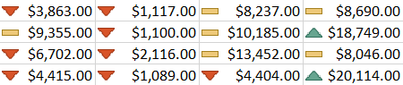

1. How to insert border in Excel with Format Cells dialog?

Ans

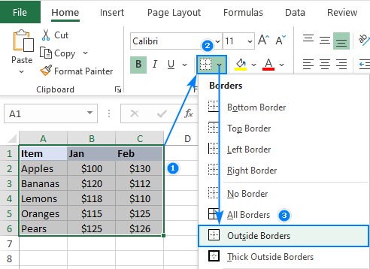

**to insert border in Excel with Format Cells dialog**

1. Select one or more cells to which you'd like to add borders.
2. Open the Format Cells dialog box by doing one of the following: ...
3. In the Format Cells dialog box, switch to the Border tab and choose the line style and color first. ...
4. When done, click OK.
5. How to Format Numbers as Currency in Excel?

Ans

To show numbers as currency, you can apply either the Currency format or the Accounting format.

(You'll find a comparison of the two formats in the [**Currency or Accounting**](https://support.microsoft.com/en-us/office/format-numbers-as-currency-in-excel-for-the-web-504781f6-9617-44f8-852a-62e363d96a98#bkmk_currencyoraccounting) section, below.)

1. Select the cells that you want to format and then, in the **Number** group on the **Home** tab, click the down arrow in the **Number Format** box.
2. Choose either **Currency** or **Accounting**.

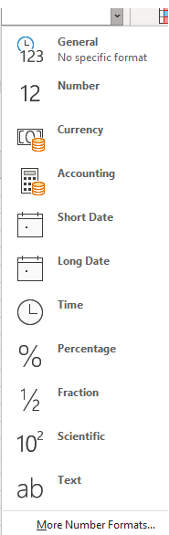

Excel for the web applies the default currency symbol and appropriate decimal places in the cells that you selected.

## **Currency or Accounting?**

While both the Currency format and the Accounting format can be used to correctly display monetary values, there are some differences between them, as shown in the following table.

| **Format** | **Description** | **Example** |
| --- | --- | --- |
| **Currency** | With this format:   * The decimal points appear aligned in the column. * The currency symbol appears next to the first digit in the cell. (That is, it is not aligned with the other currency symbols in the column. | urrency number format applied to cells |
| **Accounting** | With this format:   * Both the currency symbols and the decimal points appear aligned in the column. * Cells that contain only zeros are identified with a hyphen. * Negative numbers appear in parentheses. | ccounting number format applied to cells |

## **Change the default currency symbol**

You can’t change the default dollar currency symbol in Excel for the web just yet; but if you have the Excel desktop application, you can click **Open in Excel** and [follow the instructions here](https://support.microsoft.com/en-us/office/format-numbers-as-currency-0a03bb38-1a07-458d-9e30-2b54366bc7a4) to specify the default currency symbol that you want. After you apply the currency symbol, save your worksheet and then reopen it in Excel for the web.

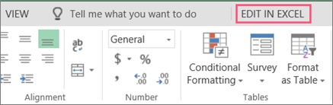

* 1. What are the steps to format numbers in Excel with the Percent style?

Ans

On the Home tab, in the Number group, click the icon next to Number to display the Format Cells dialog box. In the Format Cells dialog box, in the Category list, click Percentage. In the Decimal places box, enter the number of decimal places that you want to display.

1. What is a shortcut to merge two or more cells in excel?

Ans

**to Merge Cells in Excel Shortcut**

1. Merge Cells: ALT H+M+M.
2. Merge & Center: ALT H+M+C.
3. Merge Across: ALT H+M+A.
4. Unmerge Cells: ALT H+M+U.
   1. How do you use text commands in Excel?

Ans

**Excel Tricks: Text Functions in Excel**

1. Len () Len function in Excel helps you to know the length of a string that is number of characters in a string. ...
2. Mid () Mid function in Excel is used to extract the characters from the middle of a string. ...
3. Find () ...
4. Proper () ...
5. Rept () ...
6. Trim() ...
7. Upper() ...
8. Substitute ()